A

Project Report
O n

Project Title

Submitted By:
Your Name

In partial fulfillment for the award of the degree of

YOUR DEGREE NAME
In

College Name Or University Name

YOUR UNIVERSITY NAME
DATE-YEAR

Certificate

This is to certify that (Your Name) and research report entitled “ eg .Project Title.” is approved and is acceptable in quality and form.

_______________
Faculty Guide

date:________________
Place: :_______________

DECLARATION

I hereby declare that the project report entitled:

A Research Report on “Project Title.” submitted in partial fulfillment of the requirement for the degree of BBA/MBA, is my original work and not submitted for the award of any other degree, diploma, fellowship, or any other similar title or prizes.

Place:

Date: _________

ACKNOWLEDGEMENT

I wish to express my gratitude to all that concerned persons who have extended their kind help, guidance and suggestions without which it could not have been possible for me to complete this project report.

I am deeply indebted to my guide Mr. GUIDENAME for his valuable guidance and support at all time.

My sincere thanks to all those people who has provided me all the necessary information throughout this research report has been successfully completed at time.

Table of Contents

Sr. Number | Content | Pg. Number
1 | Certificate | 1
2 | Declaration | 2
3 | Acknowledgement | 3
4 | Table of Content | 4
5 | Executive Summery | 5
6 | Research Methodology  - Defining the Problem  - Methodology  - Choosing the Topic  - Formulating Research Questions  - Research Plain & Design  - Data Collection Mode  - Primary Data  - Secondary Data  - Objectives of Study  - Limitations of Study | 6-9
7 | Introduction | 10-15
8 | Products of BAFL | 16-25
9 | Presentation & analysis of Data Collected | 26-39
10 | Future Line of Research | 41
11 | Findings | 43
12 | Appendix  - Bibliography  - Questionnaire

Executive Summary

I have joined Bajaj Auto Finance limited for internship program (as a part of MBA) I only had a theoretical knowledge of related subject, thanks to my Faculty Guide and my Company Mentor for giving me an opportunity to implement my theoretical knowledge in practical aspect. My Company mentor Mr. Amit Nayak & Mr. Arvind Yadav have given me the project to manage the relationship with the customers. I started this project by understanding the concept & technicalities of Auto Finance. Analysis of Jabalpur market through Primary & Secondary data helped me for further strategy. The Final Report includes, the analysis of the whole data (primary and Secondary) by putting in Graphical Mode. This analysis might be a Value Addition to Bajaj Auto Finance limited to make a strategy for particular Area (JABALPUR), & help in
knowing their current market position.

RESEARCH METHODOLOGY

RESEARCH METHOLODOGY

DEFINING THE PROBLEM
First of all I discussed about the problem of the organization. Then I begin work after discussion with head of BAFL, and went to look around the environment. For this purpose I met with all the DMA(S), CSM and all other back office staff.

METHOLODOGY
Here, I’ll present the methodology which I adopted for answering my research question which I have formulated and presented earlier. Furthermore, I’ll explain that how main topic was selected, how I formulated the research question?
I’ll enlighten the way that how I collected the data concerning to my project report.

Choosing the Topic
Customer relationship is the core area of management. All study of management moves around this as customers are the central of any organization.
Now days many efforts are taken by the organization to retain the customers, such as by financial intuitions providing the special scheme is the key technique for this purpose. So I have taken interest in this key area and study has been undertaken as “marketing of financial services”.

Formulating the Research Question
After choosing the research topic, there was a concern that what should be my research question?

Research plan, Design
Towards the end of this preliminary subhead I decide sample size the method adopted for the sampling is “MULTI-STAGE random SMAPLING”. I took respondent which is nearly 30% of entire population.

DATA COLLECTION MODE
Now comes to the third stage of data collection. The tool for data collection in study is INTERVIEW-SCHEDULE & Method of data collection required for the study.

Data is the information that forms the basis of analysis, interpretation, suggestions and findings & on this basis they can be divided in two types.
- Primary Data.
- Secondary Data

Primary Data
Primary Data is defined as the information that is generated to meet the specific requirement of investigation at hand. In other words, primary data are those, which are collected by the researcher himself. These data are realistic.
The primary data collected through.

  - Direct-interview schedule
  - Questionnaire method

Secondary Data
Secondary data are those, which can’t be collected by the researcher directly. Researcher has to depend upon other sources.
These are of two types:-

- Internal Sources:-
Internal sources are company records, company annual reports, and time keeping office.

- External Source
External Sources of secondary data are collected from business references, government publications and from internet etc.

Objective of study

- To analyze the satisfaction level of customers towards BAFL.

- To increase customer’s awareness about BAFL

- To evaluate the performance of BAFL.

- To suggest any change in the present system of two wheeler finance.

- To find out areas of benefits.

LIMITATION OF STUDY
- I am aware that it is not possible to achieve the actual objective of this research in the resources available.
- The main constraint is of shortage of lack of facilities to approach the key persons of this sector.
- As time limitation for the project work is allowed for 30-45 days. It is difficult to study the customers in term of taste by habits and satisfaction.
- Many customers where very shy so that they hesitate to answer purposely of some questions.
- Some respondents were reluctant to divulge personal information which can affect the validity of all responses
- Many customers get irritated soon & provide false information.
- Sample size is limited.

In this chapter, I have explained the methodology which will be adopted in conducting this research work. I also explained that how I chose this topic and how I will collect the data.

INTRODUCTION

INTRODUCTION

COMPANY PROFILE: - BAJAJ

The Bajaj is amongst the top 10business houses in India. Its footprints stretches over a wide range of industries, spanning automobiles( two wheelers & three wheelers), home appliances lightening ,iron and steel, insurance , travel and finance.
The group’s flagship company BAJAJ AUTO is ranked as the world’s fourth largest two & three wheeler manufacturer.

BAJAJ Auto Finance Limited

Bajaj Auto Finance Limited was originally incorporated as a private limited company. It became a deemed public limited company under section 43A of the Companies Act, 1956 with effect September 24, 1988.

The company is registered with the RBI as a Non Banking Finance Company (NBFC) with effect from March 5, 1998 as per the recent reclassification by RBI; the Company has been reclassified as an Asset Finance Company.

BAFL is focused in the business of financing of Bajaj Two and three wheelers. BAFL is one of the very few NBFCs in the country to be awarded a rating of FAAA, indicating the highest level of safety of depositors' money, by the Credit Rating and Information Services India Limited (CRISIL). Network of over 300 Bajaj Auto dealerships and over 55 branch offices throughout the country to facilitate fast and flexible availability of retails finance for Bajaj vehicles.

Registered and Corporate Office

C/o. Bajaj Auto Limited, Mumbai-Pune Road, Akurdi, Pune-411 035.
Tel: +91 20 27472851;
Fax: +91 20 27484486
E-mail: baflrights@bajajfinance.in;
Website: www.bajajfinance.com

Regional Office
C/o Frontier Motors 855 North Civil Lines Nagrath Chowk Jabalpur-482001
Tel: +91 761 2628112; +91 761 4053444; +91 761 4044300
Fax: +91 761 2628112

Company’s History

YEAR 1987 –

Bajaj Auto Finance was incorporated on 25th March, as a Private Limited Company to take up Hire Purchase Finance and Lease Finance activity. It became a deemed public company by virtue of Section 43(A) of the Act with effect from 20th October 1987 and the word private was deleted by the Registrar of Companies, Maharashtra, Mumbai.
The company is primarily engaged in the Hire Purchase Financing of Two, Three Wheelers, Leasing of equipments and vehicles and Bill Discounting. The company is also engaged in Real Estate Operations as Project Management Consultant. The Company was promoted by Bajaj Auto Ltd and Bajaj and Auto Holdings Ltd.

YEAR 1992 –

The Company is proposed to enter into other areas of financing, such as Bills Discounting.
- The Company is proposed to increase the financing activities of the Company by introduction of various schemes of financing cars, trucks and leasing of equipment.
- It is proposed to increase the share capital of the Company by public issue of up to 50, 00,000 equity shares of Rs.10/- each at a premium, to be determined in consultation with the concerned Authorities.
- During the year under review, Company has opened a branch office at Hyderabad for promoting Company's financing schemes.

YEAR 1993 –

The Company has, for the first time, issued commercial Papers (CPs) to the extent of Rs.80 million. The issue of Commercial Papers has been rated as P1+ (pronounced P one plus) by The Credit Rating and Information Services of India Limited (CRISIL). This rating is the best rating for CPs.
- During the year under review, Company has opened its branch offices at New Delhi, Chennai, Bangalore and Mumbai for promoting Company's financing schemes.
- The proposal of issue of 67, 00,000 equity shares of Rs.10/- each at a premium of up to Rs.70/- per equity share was approved by the shareholders.
- It is proposed to issue shares to the public at an appropriate time and at a suitable premium after taking into account the Capital Market conditions.

YEAR 1994 –

The Company offered 64, 88,200 No. of equity shares of Rs 10 each at a premium of Rs 80 per share of which 23,13,200 shares were offered to promoters and their associates and the balance 41,75,000 shares were offered to the Indian Public. All were accepted.
- During the year under review, Company has opened its branch office at Nagpur for promoting Company's financing schemes.
- The Company is entering into financing of other automobiles mainly through the branch network.

YEAR 1995 –

During the year, Company has allotted, pursuant to a Public Issue, 4, 15,000 No. of Equity Shares of Rs.10 each for cash at a premium of Rs. 80 per Equity Share. After allotment of shares, Company's paid up share capital is Rs. 164,884,500 as at 31.3.95.
- After allotment of shares against Public Issue on 28th May, 1994, Company has ceased to be a subsidiary Company of Bajaj Auto Limited.
- The Company has opened its branch offices at Vijaywada, Nasik, Vishakhapattanam, Calcutta, Goa, Madurai and Pune for promoting Company's financing schemes.

YEAR 1996 –

The Company has obtained a credit rating of FAA+ from CRISIL for its Fixed Deposit Schemes.
- During the year, Company has opened its branch offices at Baroda and Trivandrum for promoting Company's financing schemes. The Company has a network of 15 branches.

YEAR 1997 –

Bajaj Auto Finance plans to double its borrowing capacity from Rs 100 crore to Rs 200 crore.
- The Credit Rating and Information Services of India Ltd (Crisil) has assigned P1+ ratings to the debt programmes of Wipro and Bajaj Auto Finance Ltd.
Crisil has also reaffirmed the FAAA rating assigned to the fixed deposits (FD) programme of Bajaj Auto Finance and the FA+ rating assigned to the FD programme of Vysya Bank Housing Finance Ltd.

YEAR 1998 –

Bajaj Auto Finance Ltd (BAFL), has entered into a tie-up with Godrej GE Appliances, Korean consumer durables conglomerate LG and air-conditioning major Blue Star to finance their consumer durables.
- Bajaj Auto Finance Ltd has come out with a scheme a low down payment plan to aggressively push sales of its parent company. The low down payment scheme is being launched by BAFL, along with its earlier 9 per cent interest finance scheme.
YEAR 1999 -

Bajaj Auto Finance has gone in for dematerialization of its share and joined the National Securities Depository Ltd.
- BAFL's tie-up with BPL to finance all its consumer durables except refrigerators is aimed at synergizing its existing business and adding value for its customers.
- BAFL has regional tie ups with Daewoo's in Punjab, Voltas in Andhra Pradesh, Sharp in Maharashtra and Carrier Aircon in Gujarat, some of which could be upgraded to national tie ups.

YEAR 2000 –

The Credit Rating Information Services of India Ltd (Crisil) on March 6 reaffirmed the EAAA rating for the fixed deposit programme of Bajaj Auto Finance Ltd (BAFL). The company's Rs 10-crore commercial paper programme has been assigned P1+ rating.

YEAR 2002-

Bajaj Auto Finance Ltd has informed that the Board has decided to reappoint Mr Dipak Poddar as Managing Director of the Company, for a further period of five years.

YEAR 2003-

-Approves to voluntarily delist the Equity Shares from Pune Stock Exchange Ltd & the Stock Exchange Ahmadabad, in accordance with the provisions of SEBI (Delisting Securities) - Guidelines 2003

YEAR 2004-

--Ties up with Bajaj Auto Finance for finance scheme on Intel Pentium 4 PC.

YEAR 2008-

- Bajaj Auto has increased the stakes in the extremely competitive 125 cc bike segment by offering its vehicles at extremely low financing rates.
- Bajaj Auto Finance Ltd has informed that the Board of Directors of the Company at its meeting held on October 22, 2008, has appointed Mr. D J Balaji Rao as an additional Director of the Company.

Balance Sheet of Bajaj Auto Finance Ltd
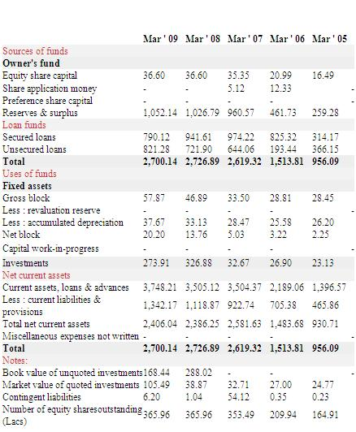

Organization Profile: - JABALPUR BRANCH

ZSM = Pream Prakash Patel

RSM = Ashish Sapte (MP & CG)

ASM = Syam Sunadar Sharma (MP & CG)

CSM = Amit Nayak Jabalpur

DMA =
- Amit Khatri (HO)
- Ram Nivas Shukla (MM Branch)
- Indar Kumar Patel (HO)
- Sharlendra Kesarvani (RJ Branch)
- Abhishek Sen (Sai Motors )
- Suryansh Tiwari ( Lakshya Motors )

Data Entry Operator = Bharat Karoshia

Products of BAJAJ Auto

Finance Limited

BUSSINESS LOANS

Features:-
Business Loans are unsecured loan which can be availed for your business use without providing security or guarantors. Business Loans could be taken for your business expansion, consolidating liability, repaying existing loans or any other immediate business requirement.

Bajaj Finance Business loans are offered from Rs.3 lacs to Rs.30 lacs which can be repaid in 12 - 36 monthly installments. Bajaj Finance Business Loans comes with the following unique features:

- Free Personal Accident Insurance of up to Rs 5 lacs
- Prompt Repayment Benefits
- No Foreclosure Charges

Benefits:-
Bajaj Finance Business Loans comes with the following exclusive benefits:
- Free Personal Accident Insurance of up to Rs 5 lacs - In case of untoward incident you would be covered with a personal accident insurance up to Rs 5 lacs.
- Prompt Repayment Benefit - You get refund of 50% of the processing fee charged if you clear all your monthly installment on time.
- Nil Foreclosure Charges -If you want to repay your loan, please go ahead, we do not charge any foreclosure charges if the loan is closed after repaying 6 monthly installments

CONSUMER DURABLE LOANS

Features
Bajaj Finance, the sole organized financier in the market offering Consumer Durable loans offers you Dreams on EMI, with 0% finance options also available. CD loans are EMI loans for Consumer Durable items like Washing Machines, Refrigerators, Color TV's, LCD's etc. These CD loans come at a very reasonable price, with a very simple process. You can just walk into one of our Dealer partner showrooms and avail of this facility for the item of your choice. Loans are available for amounts more than Rs.7500. Multiple Credit programs are also available to suit your fitment

Benefits
- 0% finance options available (for select schemes).
- Simple process with minimum documentation.
- On the spot approvals with fastest processing.
- Flexible repayment options.
- ECS clearing, reducing hassle of arranging cheques.
- Extended Warranty available.

INSURANCE SERVICES

Bajaj Auto Finance Limited (BAFL) has tied up with Bajaj Allianz Life (part of Bajaj Group), to offer a rich bouquet of world class life insurance products to suit the financial needs of all segments of buyers through different stages of their lives. With its successful track record and its highly acclaimed standing, Bajaj Allianz Life Insurance Company (BALIC) prides on serving over 8 million Indian customers. BAFL shares BALIC's philosophy of providing insurance solutions relevant to the customer's needs.

IT PRODUCT LOANS

Features
Bajaj Finance, the sole organized financier in the market offering IT Product loans, offers your Dream Desktop/Laptop on EMI, with 0% options also available. These IT Product loans come at a very reasonable price, with a very simple process. You can just walk into one of our Dealer partner showrooms and avail of this facility for the item of your choice. PC loans are available up to 100% of the product price. Loans are available for amounts above Rs. 20000.

Benefits
- 0% finance options available (for select schemes).
- Simple process with minimum documentation.
- On the spot approvals with fastest processing.
- Flexible repayment options.
- ECS clearing, reducing hassle of arranging cheques.
- Extended Warranty available.

LOAN AGAINST SHARES

Features
- Security Cover – Minimum 50%
- Tenor – Loans offered for up to 12 months.
- Loan Amount – 5 crores to 25 crores
- Interest Rate – Attractive pricing
- Speedy processing in 72 hours
- Simple Documentation

Benefits

- Quick Disbursement
- Meeting immediate liquidity requirement
- No need to sell equity shares.

LOAN AGAINST PROPERTIES

Features
Loan against Property is a Loan facility which a person or an entity avails by keeping property as collateral. Bajaj Finance offers Loan against Property for all your business and personal needs - whether you need money for your business expansion, working capital, loan consolidation, marriage in the family, children’s education or any other need you may have. The loans are available up to Rs.10 Crores and can be paid back over a comfortable term up to 15 years. We offer you a wide range of products to choose from:
- Loan Against Residential Property
- Loan Against Commercial Property
- Loan for Purchase of Commercial Property
- Loan Against Plot

To meet the needs of our entire customer we bring you a complete suite of programs that are tailor made to your requirements, you can avail a loan under any of the following programs:

- Normal Income Program: You can avail loan basis your financial statements.
- Debt Consolidator: If you have multiple loans running and want to consolidate to one single EMI this has been designed just for you. There is also a flexibility of availing additional loan under this program.
- Alternate Income Program: You can avail of loans up to Rs. 1 Crore under our Low LTV and Banking programs, which have been designed specifically to meet your requirements in a quick and hassle free manner.

Benefits

Bajaj Finance Loan against Property comes with the following exclusive benefits:
- Nil Prepayment Charges – You have the flexibility of partially or completely repaying your loan at any point of time!
We do not levy any charges on partial (1 EMI or more) or complete closure of your loan after repayment of 6 monthly installments.
- Prompts Repayment Reward – You will be rewarded for repaying your loan in time! We pay you 1% of the Equated Monthly Installment (EMI) paid in the first 12 months subject to timely clearance and no defaults. This amount shall be sent to you as a token of appreciation from Bajaj Finance at the end of the 13thmonth.
- Free Personal Accident Insurance – You are given a completely free Personal Accident Coverage! In case of untoward incident you would be covered with a personal accident insurance up to Rs. 10 Lacs.

PERSONAL LOANS

Features
Personal Loans are the cash loan which can be availed for your own personal use without providing security or guarantors. Personal Loans could be taken for renovation of your home, marriage in the family, a holiday with your family, your child's education, medical expenses or any other emergencies. Bajaj Finance Personal loans are offered from Rs. 3 lacs to Rs. 30 lacs which can be repaid in 12 - 60 monthly installments. Bajaj Finance Personal Loans comes with the following unique features:
- Free Personal Accident Insurance of up to Rs 5 lacs
- Prompt Repayment Benefits
- No Foreclosure Charges

Benefits
Bajaj Finance Personal Loans comes with the following exclusive benefits:
- Free Personal Accident Insurance of up to Rs 5 lacs - In case of untoward incident you would be covered with a personal accident insurance up to Rs 5 lacs.
- Prompts Repayment Benefit - You get refund of 50% of the processing fee charged if you clear your entire monthly installment on time.
- Nil Foreclosure Charges -If you want to repay your loan, please go ahead, we do not charge any foreclosure charges if the loan is closed after repaying 6 monthly installments as per repayment schedule

TWO WHEELER LOANS

Features & Benefits

Bajaj Auto Finance Ltd offers attractive loans for purchase of new Bajaj vehicles.
Bajaj Finance executives are available at most of the Bajaj Auto dealerships to offer finance schemes to suit the requirements of individuals.
Bajaj Finance is the only finance company to offer a unique Extended Warranty on the two wheelers financed by it. Bajaj Finance also finances Bajaj three wheelers.

Eligibility & Documentation

Eligibility Criteria

- The eligibility criteria for a Two Wheeler Loan are:
- You are a salaried or self-employed individual.
- You are between =>21 years (at the time of application) and <= 65 years (at the end of the loan tenor).
- Your minimum gross income is equivalent to Rs. 54,000/- p.a. if you reside in Mumbai, Delhi, and Chennai, Bangalore, Calcutta, Pune and Rs. 42,000 /- p.a. for all other cities.
- You have been residing for at least 1 year in the city.
- At least 1 year at the given residence address (In case of transfer from other location with less than 1 year at current location - please provide relevant documents to the bank during loan approval stage).
- You have been working for at least 1 year.
- You have a phone at your residence or office.

Documentation required applying for a Two Wheeler Loan is absolutely simple. All you need is:

- Proof Of Identity :
Any one of Passport Copy/ Photo Credit card- front & reverse/ Voters ID card/ Driving License/ PAN card/ Copy of Company ID card of MNC/ Public Ltd./ PSU/ Govt. company/ Ration Card (If Photo is given).

- Address Proof :
Any one of Passport Copy/ Voters ID card/ Driving License/ Rental agreement/ Telephone Bill/ Electricity bill/ Gas Connection Bills/ Ration Card/ Sale deed/ Property purchase agreement/ Credit Card billing statement (latest)/ LIC policy/ Letter from Company or Company provided Accommodation (List of the company's as per the Banks List- ID card of MNC/ Public Ltd.,/ PSU/ Govt. Company Containing the residence address), Address proof in the name of the applicant's Spouse or parents name is acceptable.

- Income Proof For Salaried :
Latest Salary slip for Govt. employees; If Salary slip is not available, only salary certificate to be accepted with deductions,
For Partnership/ Proprietary firms & Pvt. Ltd. CO’s- Salary Certificate to be accepted with the following mitigates: Salary Certificate to clearly state the deductions, Name & Designation of the authorized signatory.
For self-employed - Copy of the latest I.T. return.

Procedure of providing/getting Two Wheeler Loan

- Arrival of customers
First of all customer (s) enters in to a showroom and esquires about the vehicle he/she wants to purchase after it he comes to finance counter which is available in the every Bajaj two wheeler showroom there BAFL’S DMA(S) are present .

- Analyzing customer’s requirement
BAFL’S DMA(S) who are present their analyze the customer’s requirement and then offers finance schemes to suit the requirements of individuals
- Convincing providing finance scheme according to the need of the customer
DMA(S) provides number of scheme to the customer normally two or three and convince them to the best suited finance scheme

- If they are satisfied –

  - Collecting the document required for finance
Document which are required for getting two wheeler finance are mentioned above
  - filling the application forms
After collecting documents which are required for finance of two wheeler application form is filled by DMA(S)
  - Noting the FI fire
After application form is filled all the documents are enclosed with it and send to CSM, then CSM or DATA ENTERY OPERATOR notify the case to field inspection agency for FI fire
  - If not satisfied step 4 is repeated until customer is totally satisfied with the scheme after a certain TAT (Turn around Time) there are four possible outcomes of FI fire they are Positive, Negative, Refer to credit, HO Approval.

    - Positive
When FI is positive it is assumed that customer who had applied for two wheeler loan has a good or no credit history and vehicle can be delivered to him /her
    - Negative
When FI is negative it is assumed that customer who had applied for two wheeler loan do not has a good credit history and vehicle cannot be delivered to him /her.

Negative FI includes persons
      - Living in negative areas
      - With negative profile ( Politicians, Bar owners Looters etc)
      - Refer to credit
Due to reasons written below some cases are referred to CSM
      - Poor living condition
      - Low Salary/Low earning
      - Caution Profile (Police, Advocate)
      - Dowry Cases
Then CSM will take decision that whether to allow for credit or not on the basis of following criteria
      - Good Banking
      - Income from other sources
      - Old credit track record in BAFL or other finance companies
      - High down payment
      - HO Approval
When the customer is of negative profile or of Caution Profile may the vehicle is to be given as Dowry & customer is having either Good Banking /High down payment / Good old credit track record in BAFL or other finance companies/ High down payment then case is sent for HO Approval to ASM (Shyam Sunder Sharma)
Then ASM will take decision that whether to allow for credit or not on the basis of following criteria
      - Good Banking
      - Income from other sources
      - Old credit track record in BAFL or other finance companies
      - High down payment

  - Doing the Tele verification
Tele verification is a process of verification of correctness of information provided by the applicant using telephone. It has two parts RESIDENCE Tele verification & office Tele verification. It is done either by CSM or by DATA ENTRY OPERATOR.

- Now if everything is ok CSM will issue APPROVAL CUM DELIVERY ORDER, which is valid for 7 days from the date of issue or till the expiry of the scheme whichever is earlier. This is address to the dealers it includes name & address of applicant and scheme detail which is given to the applicant.

- After getting APPROVAL CUM DELIVERY ORDER DMA(S) can deliver the vehicle to the customer (applicant).

- Post Delivery Process

- Filling of Disbursement memo
- Scanning Disbursement Memo
- Hard copy of loan agreement is sent to
BAJAJ AUTO FINANCE LIMITED
AKRUDI PUNE
411035 INDIA
- PDC pouch is sent to Accounts department of
BAJAJ AUTO FINANCE LIMITED
AKRUDI PUNE
411035 INDIA

CONTENT OF AUTO LOAN Application form

- BRANCH CODE
- PROPOSAL NUMBER & DATE
- CONTACT NUMBER & DATE
- PERSONAL DETAILS OF APPLICANT
- CONTACT DETAILS
- EMPLOYMENT/BUSINESS DETAILS
- REFERENCES DETAILS
- PRODUCT DETAILS
- FINANCE DETAILS
- POST DATED CHEQUES DETAILS
- DECLARATION
- SANCTION DETAILS

CONTENT OF AUTO LOAN AGRIMENT

Promissory note: - it is signed by the customer and after singing it he/she will be liable to pay dues and penalty if any on him/her
  - Schedule forming part of auto Loan agreement :- It Includes the details of customer (Applicant) viz
    - Name
    - Address
    - Bank Name
    - Down payment
    - Product detail
    - Dealers name & address
    - Penal charges for default
    - Product insurable value
    - EMI details

  - Sales receipt :-If in case customer found to be defaulter after paying few initial installment and does not pay the rest of the installments, his/her vehicle is seized & after it company want to sell the vehicle to another person this will be the sales receipt for him/her.

  - FORM 26 (Duplicate):- If registration certificate get destructed or lost during the HPA period it is an application for the duplicate copy of the same.

  - FORM 28 (Triplicate):- It is a form of application for “NO objection certificate” and grant of certificate.

  - FORM 29 (Duplicate):- It is a form of transfer of ownership of Motor Vehicle.

  - FORM 30 (Duplicate):- It is a form of report of transfer of ownership of Motor Vehicle.

  - FORM 35(Duplicate):- It is a form of Notice of termination of an agreement of Hirer purchase/Lease/Hypothecation.

  - Loan Term Sheet:- It Includes the details of customer (Applicant) viz
    - Name of Borrower
    - Address of Borrower
    - Bank Name of Borrower
    - Amount financed
    - Down payment
    - Rate of interest
    - Product detail
    - Dealers name & address
    - PDC details
    - First due date range
    - EMI details

PRESENTATION &

analysis OF DATA

collected

PRESENTATION AND analysis OF DATA collected

QUESTIONS TO CUSTOMERS

Q1. Do you have two-wheeler?

OPTIONS | NUMBER OF RESPONDENTS
YES | 25
NO | 14

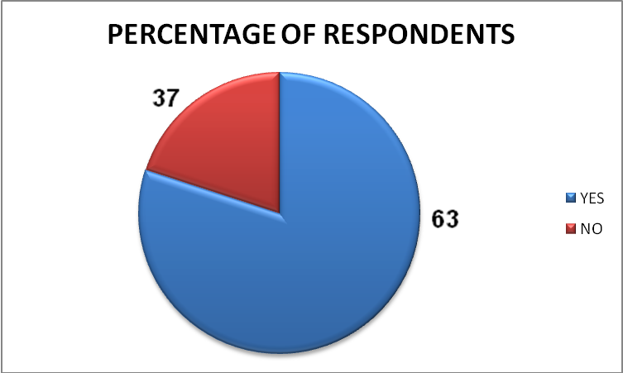

INTERPRETATION:-
I have done the survey on 39 people about BAFL and effectiveness of its schemes. In Jabalpur when I met to the people that do you have two-wheeler then 63% people told me yes I have it but 37% people told that they do not have it.

Q.2 Which Company’s Motorcycle you are using now?

OPTIONS | NUMBER OF RESPONDENTS
BAJAJ | 12
HERO HONDA | 11
TVS | 7
OTHERS | 9

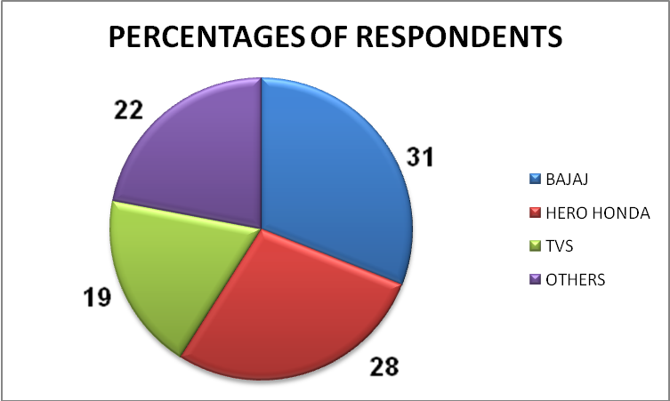

INTERPRETATION:-
When I asked second question to the people i.e. Which Company’s Motorcycle you are using now? Then I found that most of them are Bajaj’s existing customers nearly about 31% & others about 69% are switching towards Bajaj from other brands due to good service, less formalities, quick finance etc.

Q.3 Have you ever get your vehicle financed?

OPTIONS | NUMBER OF RESPONDENTS
YES | 32
NO | 7

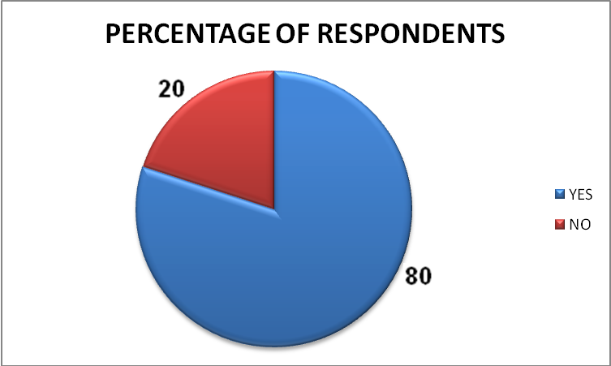

INTERPRETATION:-
When I asked third question to the people i.e. have you ever get your vehicle financed? Then I found that most of them do have the knowledge about two wheeler finance & they have got their two wheeler financed either from Bajaj or any other financial service provider earlier. It’s nearly about 80% of people have got their two wheeler financed before it.

Q.4 Did the Scheme of BAFL Attract You?

OPTIONS | NUMBER OF RESPONDENTS
YES | 16
NO | 7
SOMETIME | 8
DEPEND ON SCHEME | 8

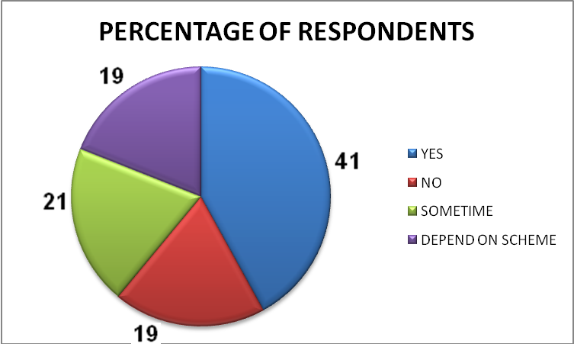

NTERPRETATION:-
When I asked fourth question to the people i.e. did the Scheme of BAFL Attract You? Then I found that most of them are attracted by the scheme introduced by BAFL. But with some of them it’s a coincidence that their arrival and scheme’s arrival has occurred simotaniously. Some peoples are attracted by some schemes only.

Q.5 how do you come to know about this scheme from BAFL?

OPTIONS | NUMBER OF RESPONDENTS
FRIENDS | 18
TV NEWS CHANNEL | 7
NEWSPAPERS/MAGAZINES | 6
OTHER SOURCES | 8

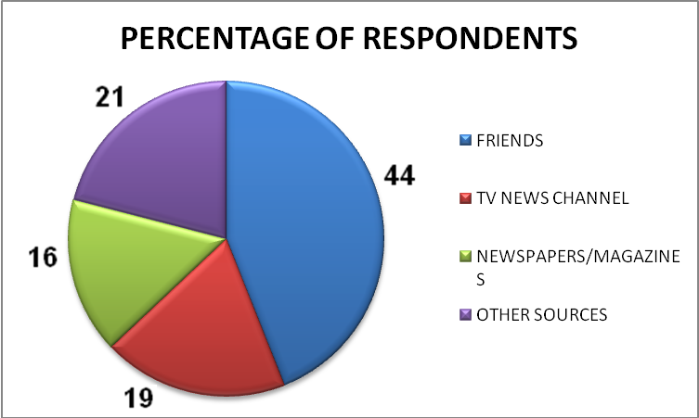

INTERPRETATION:-
When I have asked fifth question to the people i.e. how do you come to know about this scheme from BAFL? Then I found that nearly 44% of them got knowledge about the special schemes from BAFL either from their friends or relatives this means most of the customers are satisfied and they are doing mouth publicity which is good for BAFL. Nearly about 56% of respondents got it from other sources like newspapers, news channels and others.

Q.6 Is the scheme is really beneficial?

OPTIONS | NUMBER OF RESPONDENTS
YES | 20
NO | 7
SOMETIME | 8
DEPEND ON SCHEME | 4

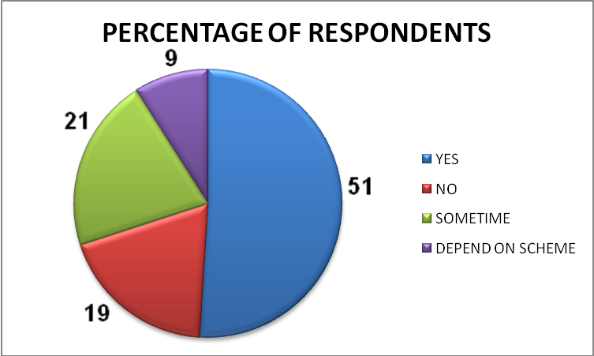

INTERPRETATION:-
When I asked; is the scheme is really beneficial for them? i.e. did you get any extra benefit by getting your vehicle financed from BAFL? Then I found that most of them are saying that yes it is beneficial it has low rate of interest as compared to others. Some are not able to analyze there benefit due to lack of knowledge.

Q.7- Is the Scheme BAFL Is Different From Other Banks/Financial Service Providers?

OPTIONS | NUMBER OF RESPONDENTS
YES | 17
NO | 11
NO IDEA | 8
NO COMMENTS | 3

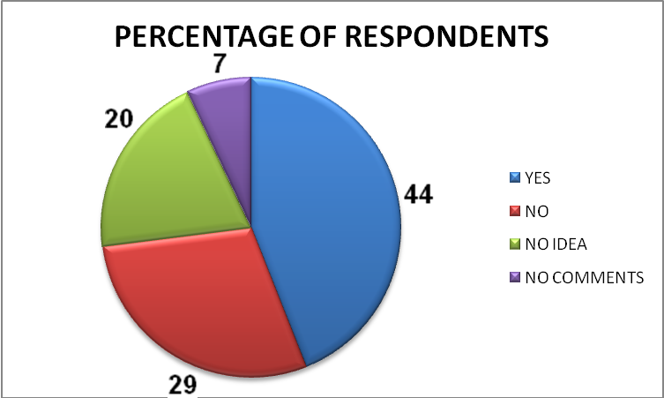

INTERPRETATION:-
When I asked seventh question to the people i.e. The Scheme BAFL Is Different from Other Banks/Financial Service Providers. I have asked this question from 26 peoples because 13 out of 26 peoples are using this type of service for first time.

Q.8 Did You Switch To BAFL Because Of Good Scheme?

OPTIONS | NUMBER OF RESPONDENTS
YES | 18
SOME WHAT | 6
MAY NOT | 10
NO | 5

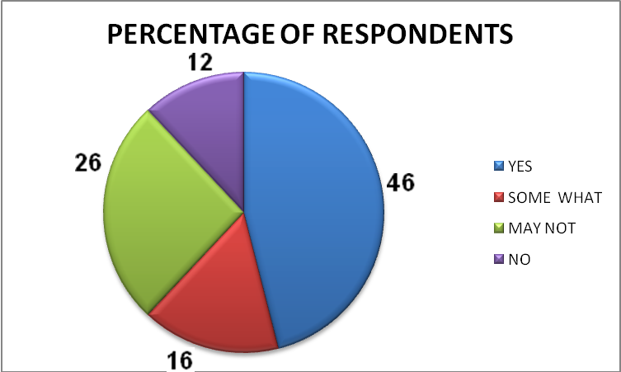

INTERPRETATION:-
When I asked eighth question to the people i.e. Did You Switch To BAFL Because Of Good Scheme? I have asked this question from 26 peoples because 13 out of 26 peoples as I have done in seventh question almost half of the respondents told me yes the schemes of BAFL allures them to get their vehicles financed from BAFL and this is due to good schemes of low rate of interest & some of low DP.

Q.9 Did You Only Seen The Scheme Before Buying Motorcycle?

OPTIONS | NUMBER OF RESPONDENTS
YES | 22
SOME WHAT | 6
MAY NOT | 4
NO | 7

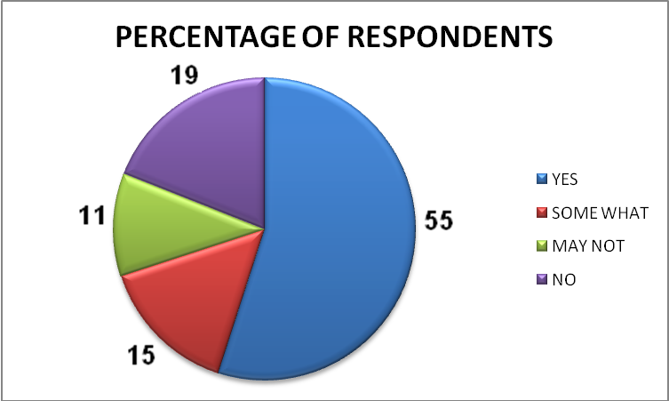

INTERPRETATION:-
When I have asked tenth question to the people i.e. did you only seen the scheme before Buying Motorcycle? Most of them have said that it does not matter which vehicle we shall purchase but the scheme does matter. If any other company provide better scheme they will switch to company.

Q.10 Did you waited for scheme before buying Motorcycle?

OPTIONS | NUMBER OF RESPONDENTS
YES | 25
NO | 14

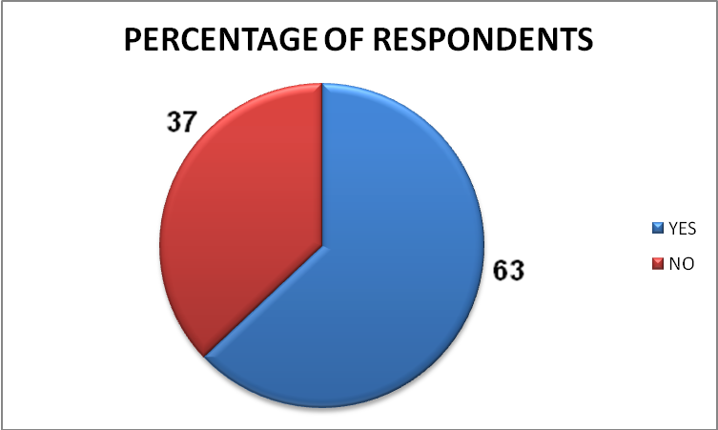

INTERPRETATION:-
When I asked eleventh question to the people i.e. did you waited for scheme before Buying Motorcycle? Then I found that most of them do have waited for any type of special scheme such Low DP Low ROI etc to get their two wheeler financed. Most of them are waiting since long for this purpose.

Q.11 Would You Suggest Your Friend to get vehicle financed from BAFL?

OPTIONS | NUMBER OF RESPONDENTS
DEFINITELY | 22
SOME WHAT | 9
MAY NOT | 6
DEFINITELY NOT | 2

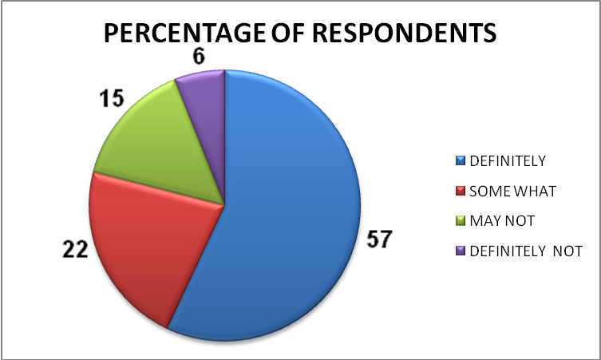

INTERPRETATION:-
When I have asked this question most of them told me that they are very much impressed from loan approval procedure of BAFL & satisfied from the service which has been provided to them by BAFL so they will also suggest their friend to get vehicle financed from BAFL. Some of them are not sure that they will suggest or not. Nearly about 6% of total respondents are not satisfied and they will never suggest any one to get vehicle financed from BAFL.

Q.12 Are you satisfied with behavior of the DMA(S)?

OPTIONS | NUMBER OF RESPONDENTS
YES | 28
NO | 11

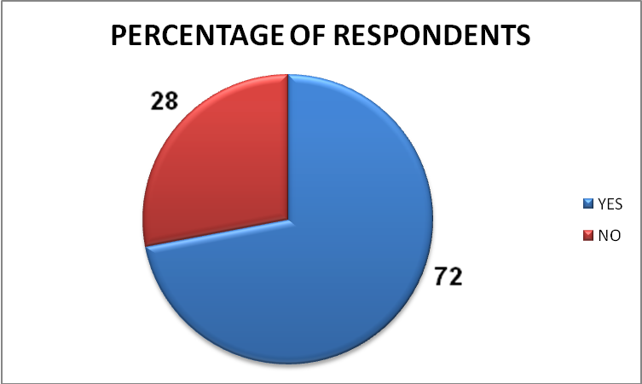

INTERPRETATION:-
When I asked this question to the people i.e. are you satisfied with behavior of the DMA(S)? Then I found that most of them are satisfied with the behavior of DMA(S).

QUESTIONS TO THE FINANCIAL INSTITUTION

Q.1 Is there any Promotional Scheme On Pulsar DTSI?
Ans. Yes there is one promotional scheme on Pulsar DTSI which is of low rate of interest. Normally we charges 13.5% ROI per annum on Pulsar DTSI but now we are charging 9.99% ROI on Pulsar DTSI.

Q.2 Are Customers getting attracted by new scheme on Pulsar DTSI?
Ans. Yes customers are getting attracted by this scheme because they have to pay less amount of interest on their loan as compared to other financial service providers.

Q.3 Is sales increase after Scheme?
Ans. Yes definitely sales has increased more customers are now willing to take benefit of this newly launched scheme.

Q.4 How much sales increase after Scheme?
Ans. After launching this new scheme more and more peoples are Eger to take benefit of this scheme but we can’t provide these special schemes to every one. Sales have increased near about 30-60%.

Q.5 Does the Bajaj Auto Ltd. provides you promotional material?
Ans. Yes some times Bajaj auto provides us some promotional materials like Banners, Canopy kit free gift for customers etc.

Q.6 What Is the Effect on Profitability?
Ans. Its quite clear from the questions asked earlier that profitability has increased.

Q.7 Are Customers switching towards Pulsar DTSI from Other vehicle after Scheme?
Ans. Yes customers are switching towards Pulsar DTSI from Other vehicle after the arrival of Scheme. Many of them are switching from other vehicles towards Pulsar DTSI due to low ROI.

Q.8 Do you think customers are easily convinced by scheme available on Pulsar?
Ans. No not always some of the customers irritate us by asking alternative schemes, we have to explain them number of schemes to them to get them convinced.

Q.9 Does the dealer has kept higher stock of Pulsar during the scheme?
Ans. Sometimes and sometimes not.

FUTURE LINE OF RESEARCH

FUTURE LINE OF RESEARCH

The future topics for research in the organization could be setting up of an appropriate ad campaign. It is very vital to the companies’ success that the people of India know about BAFL, its products and their special features. The advertisements have to be emotionally appealing. They might also include a celebrity. The brand name of BAFL could be used to give a push to BAFL and its products.
The other area of research could be in the management of funds BAFL possesses and how it can maximize returns for its investors. A research project could be undertaken on how to ensure that the money gets invested in the right companies and earns a medium – high return on investment. Another area of research could be an analysis of the training techniques used by BAFL. A large number of changes could be introduced and this would help in saving operating costs and improving the efficiency of the firm.

FINDINGS & SUGGESTIONS

FINDINGS & SUGGESTIONS

- More then half of the respondents have two wheelers.
- I found that most of them are Bajaj’s existing customers
- Further I found that nearly about 80% of people have got their two wheeler financed before it.
- I found that most of them are attracted by the scheme introduced by BAFL. But with some of them it’s a coincidence only.
- I found that nearly 44% of them got knowledge about the special schemes from BAFL either from their friends or relatives this means most of the customers are satisfied and they are doing mouth publicity.
- I found that most of them do have waited for any type of special scheme such Low DP Low ROI etc to get their two wheeler financed.
- Customers are very much impressed from loan approval procedure of BAFL & satisfied from the service which has been provided to them by BAFL so they will also suggest their friend to get vehicle financed from BAFL.
- Sales has increased more customers are now willing to take benefit of this newly launched scheme.
- Customers are switching towards Pulsar DTSI from Other vehicle after the arrival of Scheme.
- In spite of these questionnaire based following are the observation based findings

DATE(JUNE 09) | PRODUCT | DOWN PAYMENT
1 | PUL 150 | 3441
1 | PLATINA100 | 17507
2 | PLATINA 125 | 22150
3 | PUL 180 | 38400
3 | PUL 150 | 5653
4 | XCD 125 | 27981
4 | PUL 180 | 30166
4 | PUL 150 | 33757
4 | PUL 150 | 24783
4 | PUL 150 | 43080
5 | PUL 220 | 32761
5 | PUL 150 | 25548
8 | KRISTAL | 13723
11 | DISCOVER | 17182
12 | PLATINA 125 | 30150
15 | PUL 180 | 40896
19 | DISCOVER | 29398
26 | PUL 150 | 29034
26 | PLATINA 125 | 24381
28 | XCD 135 | 17026
Table showing product wise distribution of Bajaj’s vehicles financed

- 55% of customers prefer to buy motorcycles of having power equal to 150CC or more then 150CC,(According to the table mentioned above).
- Customers about 45% prefer to buy motorcycles of having power equal to 150CC or more then 150CC,(According to the table mentioned above).
- About 45 % of customers prefer to pay Down Payment between 35 to 50% of vehicle’s price, (According to the table mentioned above).
- About 45 % of customers prefer to pay Down Payment between 50 to 70% of vehicle’s price, (According to the table mentioned above).
- About 10 % of customers prefer to pay Down Payment above 70% of vehicle’s price, (According to the table mentioned above).

APPENDEX

BIBLOGRAPHY

WEBSITES

- WWW.BAJAJFINANCE.COM
- WWW.BAJAJAUTO.COM
- WWW.CORPORATEINFORMATION.COM
- WWW.GOODLE.COM/FINANCE
- WWW.FAQ.ORG

BOOKS

- KHOTARI C.R. (2000), ‘RESEARCH METHODOLOGY’, WISHWA PRAKASHAN, NEW DELHI.
- KOTLER, PHILIP, ‘MARKETING MANAGEMENT ANALYSIS’ NEW DHELI PRENTICE HALL OF INDIA1994.
- DR. O. R. KRISHNASWAMI (2008), ‘RESEARCH METHODOLOGY AND STATICAL TOOLS’ HIMALYA PUBLISHING HOUSE, MUMBAI.
- “ The AUTO Car”, June 2009,

QUESTIONNAIRE
TO THE CUSTOMER

AGE: 20-30 30-40 ABOVE 40
GENDER: MALE FEMALE
INCOME (IN Rs.): 10-20 20-30 ABOVE 30 (IN THOSAND)

Q.1 Do you have two-wheeler?
A. Yes B. No

Q.2 Which Company’s Motorcycle you are using?
A. Bajaj B. Hero Honda
C. TVS D. Others

Q.3 Have you ever get your vehicle financed?
A. Yes B. No

Q.4 Did the Scheme of BAFL Attracts You?
A. Yes B. No
C. Sometime D. Depend On Scheme

Q.5 How do you come to know about this scheme from BAFL?
A. Through Friends C. Through TV News Channels
B. Newspapers/Magazines D. Other Sources

Q.6 Is the scheme is really beneficial?
A. Yes B. No
C. Sometime D. Depend On Scheme

Q.7 Is The Scheme BAFL Is Different From Other Banks/Financial Service Providers?
A. Yes B. No
C. No Idea D. No Comments

Q.8 Did You Switch To BAFL Because Of Good Scheme?
A. Yes B. No
C. Sometime D. Definitely

Q.9 Will You Suggest Your Friend to get vehicle financed from BAFL?
A. Definitely B. Some What
C. May Not D. Definitely Not

Q.10 Did You Only Seen The Scheme Before Buying Motorcycle?
A. Yes B. No
C. Sometime D. Depend On Scheme

Q.11 Did You Waited For Scheme Before Buying Motorcycle?
A. Yes B. No

Q.12 Are you satisfied with behavior of the DMA(S)?
A. Yes B. No

QUESTIONNAIRE
TO THE FINANCIAL INSTITUTION

NAME OF FINANCIAL INSTITUTION: ___________________________________________
TURNOVER (PER MONTH): < 10 LAC, 10 LAC - 30 LAC, > 30 LAC
ADDRESS: ___________________________________________________
___________________________________________________

Q.1 Is There is any Promotional Scheme On Pulsar DTSI?
A. No B. One
C. Two D. More Then Two
Q.2 Are Customers getting attracted by new scheme on Pulsar DTSI?
A. Yes B. No
C. Sometime D. Depend On Scheme?
Q.3 Is sales increase after Scheme?
A. Yes B. No
C. Sometime D. Depend On Scheme?
Q.4 How much sales increase after Scheme?
A. 0-20% B. 20-30%
C. 30-60% D. More Then 60%
Q.5 Does the Bajaj Auto Ltd. provides you promotional material?
A. Yes B. No
C. Sometime D. Depend On Scheme?
Q.6 What Is the Effect on Profitability?
A. Increase B. Decrease
C. Same D. Both A & B
Q.7 Are Customers switching towards Pulsar DTSI from Other vehicle after Scheme?
A. Yes B. No
C. Sometime D. Depend On Scheme
Q.8 Do you think customers are easily convinced by scheme available on Pulsar?
A. Yes B. No
C. Sometime D. Depend On Scheme?
Q.9 Does the dealer has kept higher stock of Pulsar during the scheme?
A. Yes B. No
C. Sometime D. Depend On Scheme?

